AP LAB 4
NAME : SHEEFA NAAZ
ROLL NO.: 2128085
DATE: 17-08-2023
SECTION : CSSE 2

- Write an R-script to create a 4*3 matrix. Now display the elements of row1, row3 and column2 of that matrix.

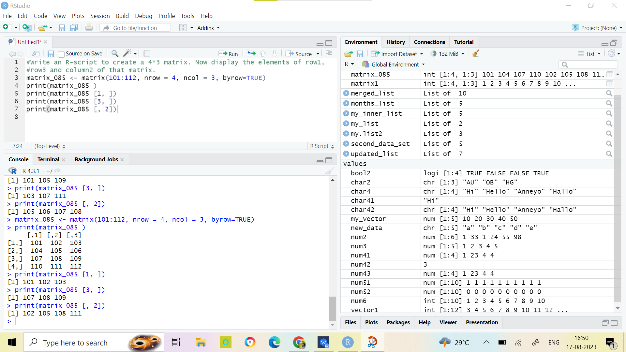

- Write an R-script to create two matrix and then perform addition, subtraction, multiplication and division of them.

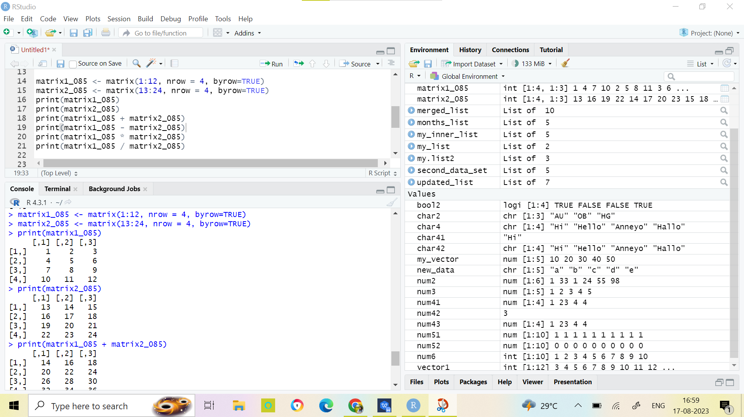

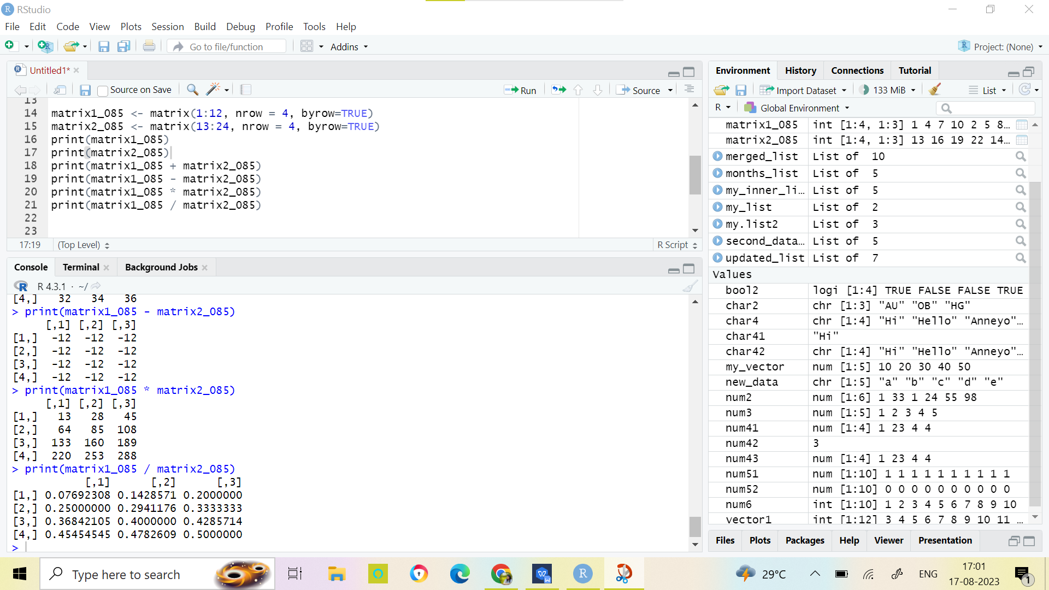

- Write an R-script to create a 3*3 matrix and update that matrix by adding 4 to each and every element, also display the updated matrix.

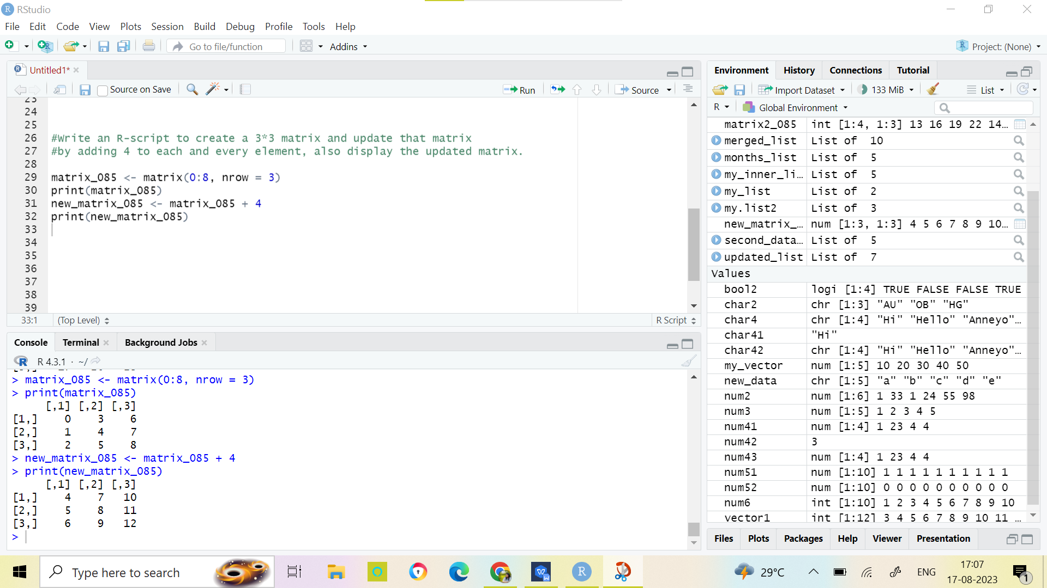

- Write an R-script to set those elements of the created matrix to 0, whose value are less than 5.

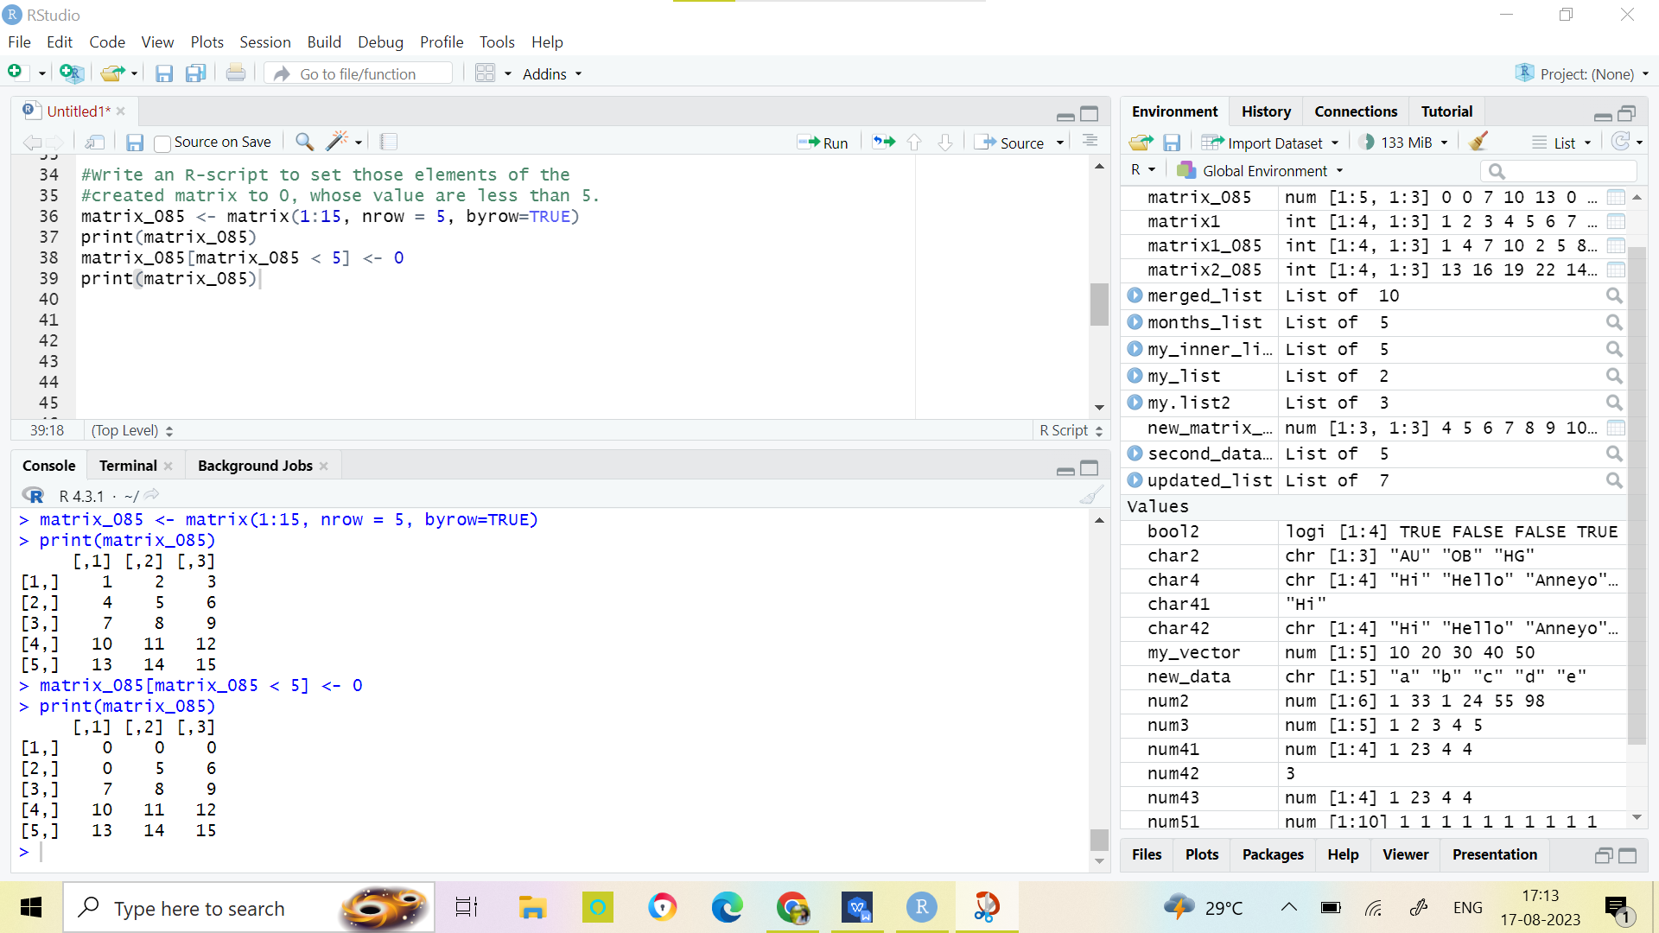

- Write an R-script to check the given matrix is symmetric matrix or not?
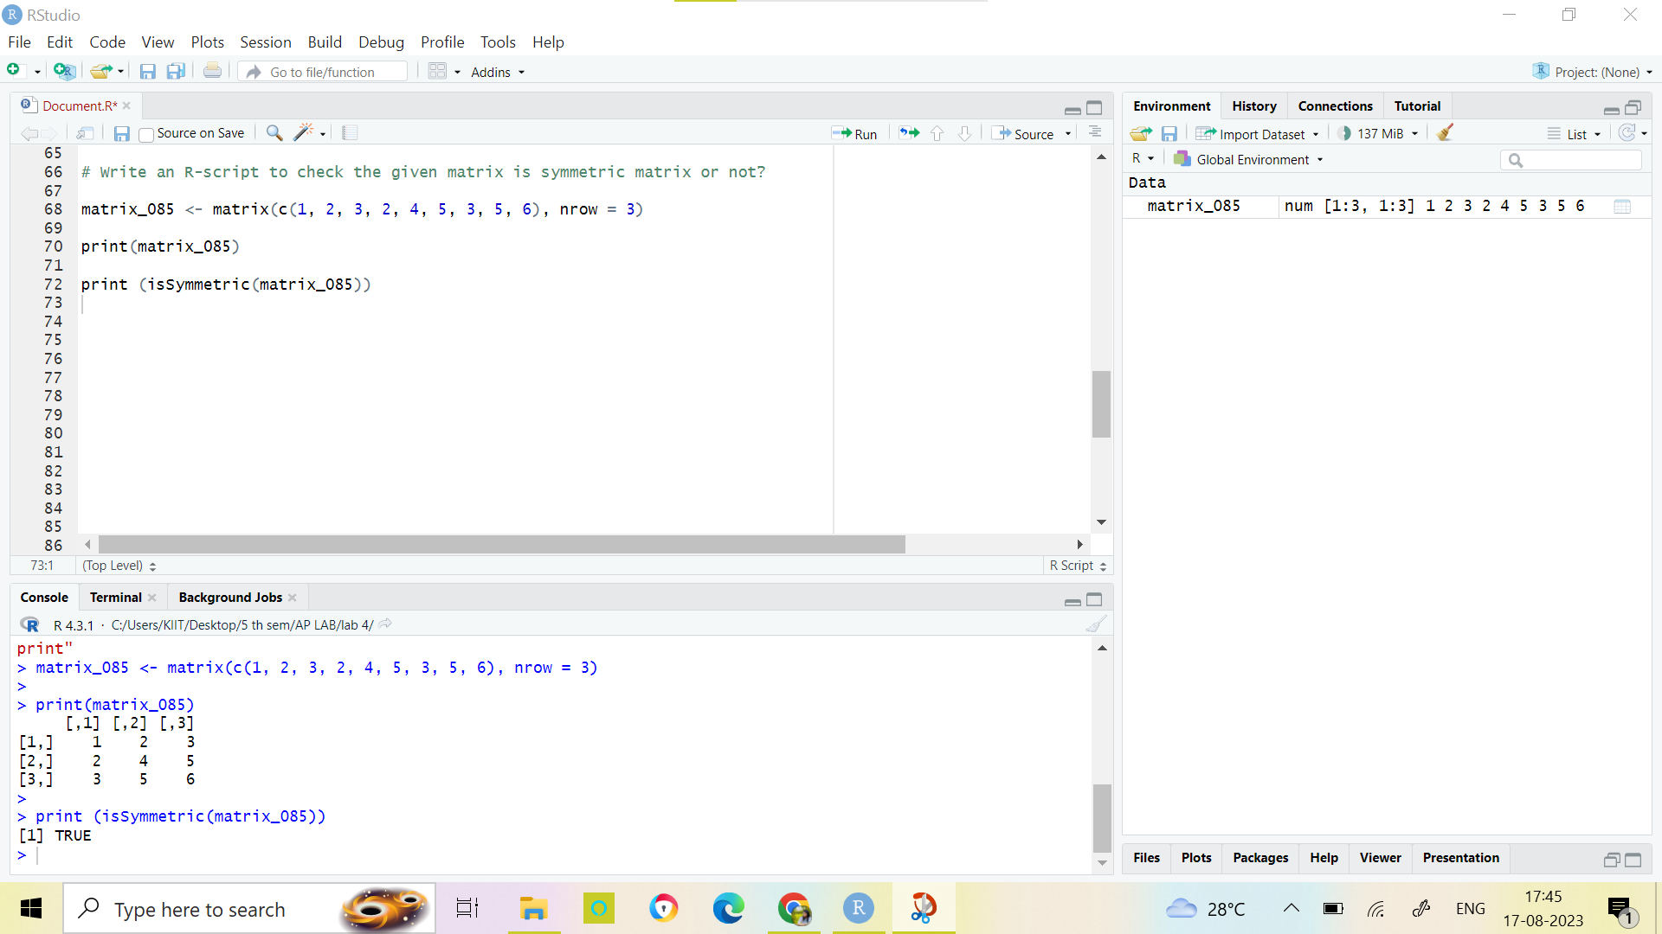

- Write an R-script to create a matrix and evaluate the sum of the elements row-wise.

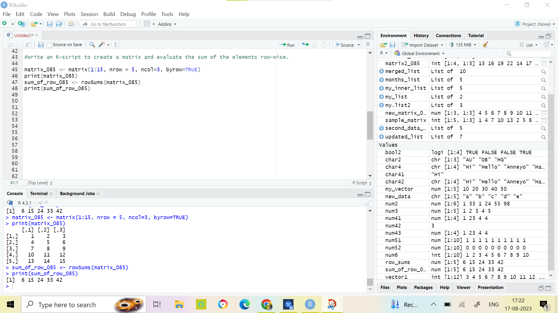

- Write an R-script to create an array having 3 dimensions. Now retrieve the elements of 2nd row of 3rd matrix.

